A Project Report on
“Low-Cost Voice-Controlled Robotic Arm for Differently Abled Individuals”
Submitted in the partial fulfillment of requirement for the award of Degree of

Bachelor of Technology in
Industrial IOT
by

Jyoti Panjwani
Khushi Shah

Monika Bidwaik
Snehal Wankhede

Guide

Prof. Ms. Divya Meshram

Department of Industrial IOT Priyadarshini College of Engineering, Nagpur-440019

(An institute affiliated to Rashtrasant Tukadoji Maharaj Nagpur University, Nagpur)

Session 2024-25

Department of Industrial IOT Priyadarshini College of Engineering, Nagpur-440019

CERTIFICATE

This is to certify that this is a bonafide record of project work entitled “Low-Cost Voice-Controlled Robotic Arm for Differently Abled Individuals” carried out by

Jyoti Panjwani Khushi Shah
Monika Bidwaik Snehal Wankhede

Students of the B.Tech., Department of Industrial IOT, during the academic year 2024- 2025, in the partial fulfillment of the requirement for the award of the degree of Bachelor of Technology (Industrial IOT) offered by the Rashtrasant Tukadoji Maharaj Nagpur University, Nagpur.

Place: Nagpur
Date:

Prof. Ms. Divya Meshram Guide (IIOT Dept.)  P.C.E, Nagpur | Dr. A. B. Jirapure (HOD IIOT)  P.C.E, Nagpur | Dr. S. A. Dhale Principal, P.C.E,  Nagpur

Department of Industrial IOT Priyadarshini College of Engineering, Nagpur-440019

DECLARATION

We here declared that the project entitled “Low-Cost Voice-Controlled Robotic Arm for Differently Abled Individuals” is submitted in the partial fulfillment of Degree of Bachelor of Technology to RTMNU Nagpur is an original work done by us. This work in the same form or in any form is not submitted by us or anyone else for award of any Degree.

Name of Students Signature

- Ms. Jyoti Panjwani

- Ms. Khushi Shah

- Ms. Monika Bidwaik

- Ms. Snehal Wankhede

Department of Industrial IOT Priyadarshini College of Engineering, Nagpur-440019

ACKNOWLEDGMENT
We express our deep sense of gratitude to our guide Prof.Ms.Divya Meshram for her help in providing reviews, ideas and suggestions that improved our project work. Because of inspiring and guidance provided by her, the project work is reached up to success level. It has been privilege and pleasure working under her guidance.
We sincerely acknowledge our deep sense of gratitude towards Dr. A.B.Jirapure, Head of the Industrial IOT Department, Priyadarshini College of Engineering, Nagpur, for his constant support and encouragement throughout the course work.
We are obliged to Dr. S. A. Dhale, Principal, Priyadarshini College of Engineering, Nagpur, for providing the requisite facilities for the completion of the project work.
We are thankful to all our professors for their guidance from time to time and inspiration at different stages of our studies. We are also thankful to all those people who are directly and indirectly helped us in the development of the project, without which this project would have not been possible.
We are grateful to the Institution Priyadarshini College of Engineering, Nagpur and
R.T.M. Nagpur University for granting permission to us to undertake this project.

Ms. Jyoti Panjwani Ms. Khushi Shah Ms. Monika Bidwaik
Ms. Snehal Wankhede

INDEX
Department of Industrial IOT Priyadarshini College of Engineering, Nagpur-440019

CONTENTS | PAGE NO.
CERTIFICATE | 2
ACKNOWLEDGEMENT | 3
ABSTRACT | 7
CHAPTER 1 | 10
INTRODUCTION | 10
1.1 Introduction | 11
1.2 Necessity | 12
1.3 Objectives | 13
CHAPTER 2 | 14
LITERATURE SURVEY | 15
CHAPTER 3 | 19
SYSTEM MODELLING | 19

3.1 Block Diagram and Circuit Diagram | 20
3.2 Description of Components | 23
3.3 Code | 28
3.4 Photograph of Project | 33
CHAPTER 4 | 34
APPLICATIONS | 35
CHAPTER 5 | 37
CONCLUSION AND FUTURE SCOPE | 38
REFERENCES | 43
ANNEXURE

Department of Industrial IOT Priyadarshini College of Engineering, Nagpur-440019

LIST OF FIGURE

Figure No. | Name of Figure |  | Page No.
3.2.1 | Circuit Diagram |  | 20  To 27
3.2.1 | 3.2.1.1 | Arduino Nano | 20  To 27
3.2.1 | 3.2.2.1 | Servo Motor | 20  To 27
3.2.1 | 3.2.3.1 | XL6009 Battery | 20  To 27
3.2.1 | 3.2.4.1 | 12V Lithium Battery: | 20  To 27
3.2.1 | 3.2.5.1 | Bluetooth Module HC-05 | 20  To 27
3.2.1 | 3.2.6.1 | PCB Board | 20  To 27
3.4.1 | Photograph Of Project |  | 33

ABSTRACT
The project titled " Low-Cost Voice-Controlled Robotic Arm for Differently Abled Individuals " aims to develop an affordable and user-friendly assistive device designed to enhance the independence and quality of life for individuals with disabilities, particularly those with congenital amputations. This robotic arm will perform predefined actions based on voice commands given through an Android phone, leveraging advanced speech recognition technology to provide an intuitive and accessible interface. The primary focus of this project will be to create a low-cost solution without compromising functionality and reliability. By integrating cost-effective hardware components and open-source software, the robotic arm will offer a practical and scalable solution for everyday tasks. Key innovative aspects of the project will include its affordability, ease of use, and customization potential for various applications. The emphasis on using low- cost hardware components and materials will ensure that the overall cost of the robotic arm remains within an affordable range for individuals and healthcare providers.

The utilization of advanced speech recognition technology will enable hands-free operation, making it accessible to users with limited mobility. The input speech will be provided through an Android phone, a widely used and user-friendly operating system, making the device easily controllable by everyone. The Android phone and robotic arm will communicate via a Bluetooth module. The hand movements will be controlled by servo motors, which will be precisely placed and aligned for specific rotations and positions. A microcontroller will receive voice commands from the smartphone and will dictate the nature of the grab based on these commands. Additionally, the user-friendly design will simplify the interaction process, ensuring ease of use for all users.

Beyond its affordability and accessibility, this project prioritizes durability and adaptability to different needs. The robotic arm will be designed with modularity in mind, allowing future enhancements, such as gesture recognition and machine learning-based adaptability for improved user experience. The system will be optimized to ensure minimal latency in response to commands, making real-time interactions smoother and

more efficient. Furthermore, the lightweight design will contribute to user comfort, reducing fatigue during prolonged use.

The project will also explore the possibility of integrating different grip modes, enabling the robotic arm to perform a variety of tasks, such as grasping utensils, picking up objects, and performing basic daily activities. This customization potential ensures that the device can be tailored to suit different users’ needs, whether for personal assistance or professional applications. Moreover, the implementation of open-source technology allows for further development by the research community, promoting innovation and improvements over time. With its emphasis on cost-effectiveness, ease of use, and continuous enhancement, this voice-controlled robotic arm has the potential to make a significant impact in assistive technology, improving the lives of individuals with disabilities.

In addition to its functional benefits, the robotic arm will undergo rigorous testing to ensure its reliability and safety. Various real-world scenarios will be simulated to assess the device’s performance under different conditions, including response time, grip strength, and overall usability. This testing phase will help refine the hardware and software components, ensuring the highest level of accuracy and efficiency. Furthermore, user feedback will be incorporated to enhance the system’s effectiveness and usability, making it more adaptable to diverse needs.

Another key aspect of the project is its potential for scalability and commercialization. By leveraging cost-effective production methods and widely available components, the design can be mass-produced and distributed at an affordable price. Collaborations with healthcare institutions, rehabilitation centers, and non-profit organizations will be explored to expand accessibility and reach a larger user base. This initiative could pave the way for future advancements in assistive robotics, contributing to a more inclusive and technologically advanced society.

Ultimately, this project aims to bridge the gap between technology and accessibility, empowering individuals with disabilities to perform everyday tasks with greater ease and independence. By prioritizing affordability, usability, and continuous innovation, the voice-controlled robotic arm stands as a testament to the potential of assistive technology in enhancing quality of life. Future iterations of the device could incorporate AI-driven adaptability, additional sensory inputs, and enhanced mechanical precision, further broadening its capabilities and impact.

CHAPTER 1 INTRODUCTION

  - Introduction

In today's rapidly advancing technological landscape, assistive devices play a crucial role in improving the quality of life for individuals with disabilities. People with congenital amputations or mobility impairments often face challenges in performing routine tasks, making them dependent on caregivers. The development of cost-effective, intelligent assistive technologies can significantly enhance their independence. A voice-controlled robotic arm represents a breakthrough in accessibility, allowing users to control the device through simple voice commands. This project integrates modern speech recognition technology with robotic control mechanisms to create a functional and affordable solution that empowers individuals with disabilities.

Traditional prosthetic solutions, while effective, often come with limitations such as high costs, lack of adaptability, and reliance on complex control mechanisms that require extensive training. Many advanced robotic prosthetics use myoelectric signals, which can be difficult for some users to operate effectively, leading to frustration and limited adoption. This project seeks to overcome these barriers by utilizing voice recognition as a simple yet powerful control mechanism. By leveraging widely available technology, such as Android smartphones and Bluetooth modules, this robotic arm aims to provide a seamless and intuitive user experience.

Additionally, with the growing demand for accessible and affordable assistive technologies, there is a pressing need to develop solutions that cater to individuals from diverse economic backgrounds. This project not only focuses on functionality but also ensures that the robotic arm is accessible to a broad spectrum of users, including those in developing regions where expensive assistive devices may not be a viable option. By focusing on cost efficiency and ease of use, this innovation aims to bridge the gap between technology and accessibility.

  - Necessity

The necessity for this project arises from the significant gaps in the current assistive technology market. Many available prosthetic and robotic assistive devices are highly expensive and beyond the reach of those who need them the most. Individuals with disabilities often face challenges in performing daily tasks such as eating, writing, or lifting objects, making them reliant on external support. This reliance can impact their self-sufficiency and overall quality of life. An affordable and efficient voice-controlled robotic arm has the potential to empower these individuals, giving them greater control over their daily activities without financial strain.

Another important aspect is the lack of customization in existing prosthetics. Traditional prosthetics are often designed for general use, with limited adaptability to specific user needs. This project aims to create a modular robotic arm that allows for various grip modes and functions, making it more versatile. By incorporating open-source software and cost-effective hardware, the device can be adapted to different use cases, ensuring that it caters to a wide range of individuals with different levels of disabilities.

Moreover, individuals with severe motor impairments may struggle with conventional prosthetics that require manual operation or complex learning curves. By integrating voice recognition, the robotic arm simplifies user interaction, making it accessible to those who may not be able to control traditional prosthetics. With the increasing adoption of speech recognition technology in consumer electronics, leveraging this technology for assistive applications can lead to a transformative impact on the lives of people with disabilities.

  - Objectives

The primary objective of this project is to develop a cost-effective, voice-controlled robotic arm that enhances the independence and quality of life for individuals with disabilities. To achieve this, the project focuses on the following key goals:

    - Affordability – Ensuring the robotic arm remains within a reasonable price range by utilizing low-cost hardware components and open-source software solutions. This will make the device accessible to individuals from different socio-economic backgrounds.
    - Ease of Use – Implementing a simple voice-command interface that allows users to operate the device without requiring extensive training or technical expertise. The device will be designed to work with widely used Android smartphones to minimize additional hardware costs.
    - Reliability and Precision – Designing a robust control system that enables smooth and accurate movement of the robotic arm for performing various tasks, such as grabbing and holding objects. The system will focus on minimizing response time to ensure real- time execution of commands.
    - Customization and Modularity – Allowing flexibility in design so that the robotic arm can be adapted for different user needs, including varied grip modes, strength adjustments, and potential gesture-based control in future iterations.
    - Wireless Connectivity – Enabling seamless communication between the robotic arm and an Android smartphone using Bluetooth technology, reducing the need for complex wiring and external control systems. This will make the device more portable and user- friendly.
    - Scalability and Future Enhancements – Providing a foundation for further development, such as the integration of AI-based adaptability, haptic feedback, and improved speech recognition algorithms. Future iterations may include machine learning algorithms that adapt to user behavior for an enhanced experience.

By meeting these objectives, the project aims to bridge the gap between accessibility and technological innovation, creating an assistive device that is both practical and transformative for individuals with disabilities. The success of this initiative could pave the way for future advancements in assistive robotics, contributing to a more inclusive and accessible society.

CHAPTER 2 LITERATURE SURVEY

Literature Survey
  - Development of Myoelectric Prosthetic Arms with Low-Cost Components

Year of Publication: 2020
Published In: International Journal of Robotics Research
This study explores the use of open-source myoelectric sensors and low-cost components to create prosthetic arms that are both functional and affordable. By leveraging advancements in electromyography (EMG) sensors and cost-effective microcontrollers, researchers have aimed to provide amputees with an alternative to high-priced commercial prosthetics. The research highlights the effectiveness of using readily available components while ensuring the prosthetic arm mimics natural limb movement efficiently.
Results: The study demonstrated that open-source components can significantly reduce the cost while maintaining functionality comparable to commercial myoelectric prosthetics.
Future Scope: Integration of AI-based adaptive control for better user experience. Limitations: Dependence on muscle signals may not be suitable for users with nerve damage.

  - Voice-Controlled Robotic Arm for Assistive Applications

Year of Publication: 2021
Published In: IEEE Transactions on Biomedical Engineering
This paper discusses the implementation of voice recognition technology to control robotic arms, particularly for individuals with motor impairments. The system employs speech-to-text conversion techniques and natural language processing to interpret user commands. It aims to enhance accessibility by offering hands-free control, reducing the need for physical interaction with a device. The research emphasizes the importance of

real-time response and command accuracy for improving the user experience.

Results: The system was successfully implemented with a 92% command recognition accuracy.
Future Scope: Improvement in noise filtering and support for multiple languages.
Limitations: High dependency on clear speech input.

  - Bluetooth-Based Communication for Assistive Devices

Year of Publication: 2020
Published In: Journal of Assistive Technologies
This research investigates the feasibility of using Bluetooth technology for real-time communication between assistive devices and mobile controllers. Bluetooth-based control systems are evaluated for their efficiency, reliability, and latency in signal transmission.

The study also examines power consumption and interference issues, highlighting the potential for further enhancement in wireless connectivity for prosthetic and assistive applications.
Results: Bluetooth communication showed reliable, real-time performance with minimal latency.
Future Scope: Exploration of alternative wireless communication methods like Wi-Fi and Zigbee.
Limitations: Limited range and potential connectivity issues.

  - Servo Motor Actuation in Prosthetic Devices

Year of Publication: 2017
Published In: Robotics and Automation Letters
The study focuses on the efficiency and reliability of servo motors in controlling robotic prosthetic limbs.

Servo motors play a crucial role in actuation by enabling precise control over movement and rotation. The research evaluates different motor configurations and their impact on the functionality of prosthetic limbs, ensuring smooth and controlled motion for users. Results: The study found servo motors provide precise control over movement and positioning.
Future Scope: Optimization of power consumption for longer battery life.
Limitations: Limited torque for heavier loads.

  - Cost-Effective 3D Printing for Prosthetic Development

Year of Publication: 2021
Published In: Additive Manufacturing Journal
This research highlights the role of 3D printing in reducing the cost of prosthetic development while maintaining quality and functionality. By utilizing additive manufacturing techniques, prosthetic limbs can be produced quickly and customized according to the user’s needs. The study compares traditional prosthetic fabrication methods with 3D printing and emphasizes the advantages in terms of affordability, customization, and production speed.
Results: 3D-printed components reduced manufacturing costs by 50%.
Future Scope: Use of biodegradable materials for sustainability.
Limitations: Strength and durability concerns.

  - Human-Computer Interaction in Assistive Robotics

Year of Publication: 2022
Published In: ACM Transactions on Human-Robot Interaction
This study evaluates different user-interface methods for assistive robotic devices, including voice and gesture-based controls. Human-computer interaction (HCI) plays a vital role in designing user-friendly assistive technologies.

The research explores how intuitive control mechanisms improve usability for people with disabilities, making assistive robots more accessible and efficient.
Results: Voice and gesture-based controls improved usability and user satisfaction.
Future Scope: AI-driven personalized user interfaces.
Limitations: Complexity in multi-input processing.

  - Gesture-Controlled Robotic Arm for Rehabilitation Therapy

Year of Publication: 2022
Published In: Journal of Rehabilitation Research and Development
This study investigates the effectiveness of gesture-based control for robotic arms in rehabilitation therapy. The system utilizes motion sensors to interpret hand and finger movements, allowing individuals with motor impairments to interact with robotic limbs more intuitively. The research focuses on improving the accuracy and responsiveness of gesture recognition algorithms for seamless control.

Results: Gesture-controlled robotic arms improved rehabilitation outcomes for stroke patients.
Future Scope: Integration with virtual reality (VR) for immersive rehabilitation.
Limitations: Difficulty in recognizing complex hand gestures.

CHAPTER 3
SYSTEM MODELLING

Circuit Diagram
The circuit diagram illustrates the interconnections between various components in the robotic arm system. It includes the microcontroller, servo motors, power supply, Bluetooth module, and sensors required for operation.
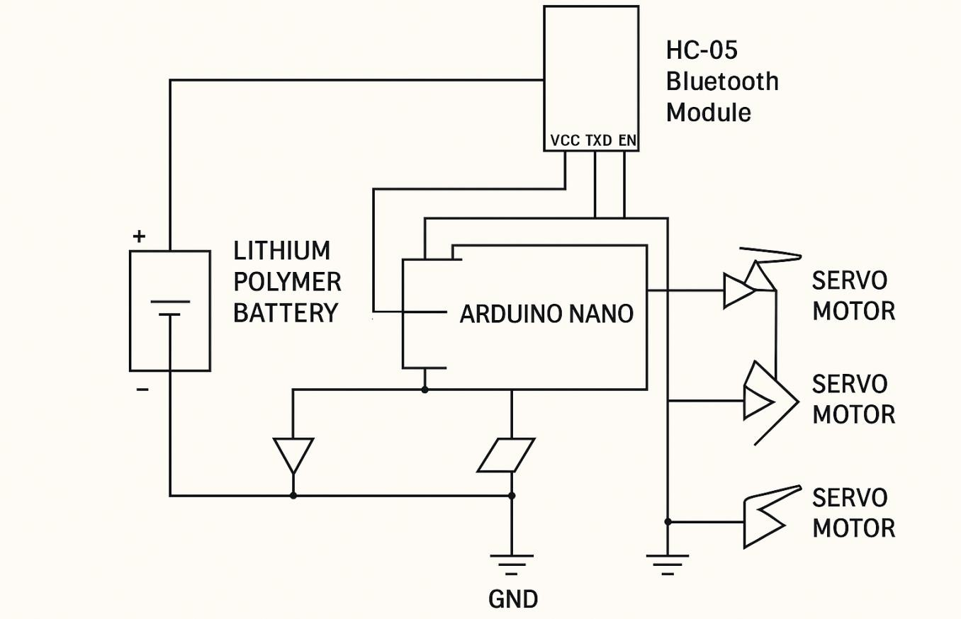

Fig. 3.2.1 Circuit Diagram

This circuit is designed to control five servo motors using an Arduino Nano, while receiving commands via an HC-05 Bluetooth module. The power is supplied by a Lithium Polymer (LiPo) battery, and a XL6009 boost converter ensures that all components receive the appropriate voltage.

Key Components and Their Roles

- Arduino Nano

- Acts as the central microcontroller.
- Receives commands from the HC-05 Bluetooth module.
- Controls the five servo motors via PWM (Pulse Width Modulation).
- Powered by the regulated output from the XL6009 boost converter.

- HC-05 Bluetooth Module

- Enables wireless communication (e.g., from a smartphone app).
- Connected to the Arduino Nano via TX (Transmit) → RX (Receive) and RX → TX.
- Uses the VCC (3.3V or 5V) and GND lines for power.

- Five Servo Motors

Each servo requires three connections: Power (VCC), Ground (GND), and Signal (PWM).

- The signal pins are connected to specific PWM-enabled pins on the Arduino Nano.
- Servos are powered by the XL6009 boost converter to ensure they receive stable voltage.

- XL6009 Boost Converter

- Boosts the LiPo battery voltage to a suitable level for the Arduino and servos.
- Takes the input voltage (e.g., 3.7V or 7.4V from the LiPo battery) and steps it up to 5V or 6V as needed.
- Output voltage is connected to the Arduino Nano and servos.
- Has an adjustable potentiometer to fine-tune the output voltage.

- Lithium Polymer (LiPo) Battery

- The primary power source for the entire system.
- Connected to the XL6009 boost converter for voltage regulation.
- Provides enough current to drive multiple servos.

Wiring Breakdown

- Power Connections

  - LiPo Battery (VCC, GND) → XL6009 Boost Converter (Input Pins).
  - XL6009 Output (e.g., 5V or 6V) → Arduino VCC, Servo Motors VCC.
  - GND of LiPo, XL6009, Arduino, HC-05, and Servos are all connected to a common ground.

- Bluetooth Module (HC-05) → Arduino Nano

  - VCC (5V) → Arduino 5V.
  - GND → GND.
  - TX (HC-05) → RX (Arduino).
  - RX (HC-05) → TX (Arduino).

- Servo Motors → Arduino Nano

  - Servo VCC → XL6009 Boost Converter Output (5V/6V).
  - Servo GND → Common GND.
  - Servo Signal Pins → Arduino PWM Pins (e.g., D3, D5, D6, D9, D10).

How It Works

- Power Regulation:

  - The LiPo battery provides raw power.
  - The XL6009 boost converter regulates and boosts the voltage as needed.
  - Arduino Nano and servos receive stable power.

- Bluetooth Communication:

  - A smartphone (or any Bluetooth controller) sends commands to the HC-05 module.
  - The HC-05 module forwards data to the Arduino Nano via serial communication.

- Servo Motor Control:

  - The Arduino processes the received command and generates appropriate PWM signals to control the five servos.
  - Servos move accordingly, based on the command received.

  - Description of Components:

    - Arduino Nano:

The Arduino Nano is a compact, breadboard-friendly microcontroller board based on the ATmega328P or ATmega168, ideal for small-scale electronics projects. It features 14 digital I/O pins (6 with PWM), 8 analog inputs, 32 KB flash memory, 2 KB SRAM, and operates at 16 MHz with a 5V supply. The board supports serial communication (UART, I2C, SPI) and is programmable via the Arduino IDE using a mini-USB or USB-C connector in newer clones. Its small size, affordability, and compatibility with numerous modules and libraries make it perfect for robotics, IoT, wearables, and education. However, it lacks onboard wireless connectivity and has limited memory for larger projects.

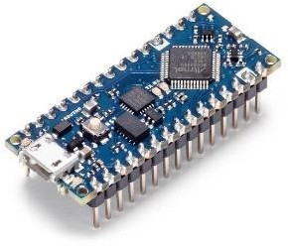

Fig 3.2.1.1 Arduino Nano

    - Servo Motors:

A servo motor is a compact, high-precision rotary actuator commonly used for precise control of angular or linear position, velocity, and acceleration. It consists of a DC motor, a position feedback mechanism (usually a potentiometer), and a control circuit. Servo motors are controlled by sending PWM (Pulse Width Modulation) signals, where the pulse width determines the motor's position.Widely used in robotics, RC vehicles, and automation systems, they offer precise movement within a limited range (usually 0–180 degrees for standard servo motors). They are valued for their accuracy, ease of use, and compatibility with micro controllers like Arduino.


Fig 3.2.2.1 Servo Motor

    - XL6009 Battery Booster:

The XL6009 is a high-performance, DC-DC step-up (boost) converter module designed for applications requiring voltage boosting. It is based on the XL6009 integrated circuit and includes an adjustable output voltage feature. The module efficiently converts a lower input voltage (3V–32V) to a higher output voltage (5V–35V), with an adjustable range controlled by a potentiometer. It has a high efficiency of up to 92%, making it ideal for battery-powered devices, solar power projects, and LED applications. Compact and affordable, the XL6009 also features a built-in 4A MOSFET switch for reliable performance, overheat protection, and stable operation.
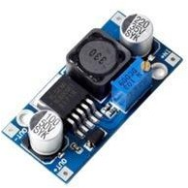

Fig 3.2.3.1 XL6009 Battery

    - 12V Lithium Battery:

A 12-volt lithium battery is a lightweight, high-performance rechargeable battery commonly used in solar systems, portable electronics, electric vehicles, and backup power applications. Available in Lithium Iron Phosphate (LiFePO4) or Lithium-ion (Li- ion) chemistries, it offers a nominal voltage of 12.8V (LiFePO4) or 11.1V (Li-ion) with charge/discharge ranges between 10V and 14.6V. These batteries are known for their high energy density, low self-discharge rate, long lifespan of 2,000– 5,000 cycles, and built-in Battery Management Systems (BMS) for protection against overcharging, over- discharging, and overheating. Compared to traditional lead-acid batteries, 12V lithium

batteries are lighter, more efficient, and deliver consistent power output, making them ideal for modern energy solutions.

Fig. 3.3.4.1 Lithium Battery

    - Bluetooth Module (HC-05):

The HC-05 Bluetooth module is an essential component of the voice-controlled robotic arm, enabling wireless communication between the robotic system and an external device such as a smartphone or computer. It operates on a 2.4 GHz frequency and utilizes the Serial Port Protocol (SPP) to facilitate seamless data transmission via UART (Universal Asynchronous Receiver-Transmitter). The module supports both master and slave modes, allowing it to either receive commands from a mobile application or send data to a connected system. It features an onboard LED indicator that displays connectivity status, flashing at different rates to indicate whether the device is in pairing mode, successfully connected, or awaiting connection.

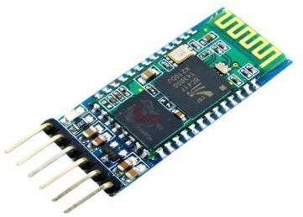

Fig 3.2.5.1 Bluetooth Module HC-05

    - PCB Board:

A PCB (Printed Circuit Board) is a flat, rigid board used to mechanically support and electrically connect electronic components using conductive pathways, tracks, or signal traces etched from copper sheets laminated onto a non-conductive substrate. PCBs are essential in almost all electronic devices, from simple gadgets to complex industrial machinery. They can range from single-layer boards for basic circuits to multi-layer boards for advanced applications. Components like resistors, capacitors, microcontrollers, and ICs are soldered onto the PCB. Modern PCBs may also include surface-mount components and integrated circuit traces for compact designs. Their durability, scalability, and precision make them indispensable in electronics manufacturing and prototyping.
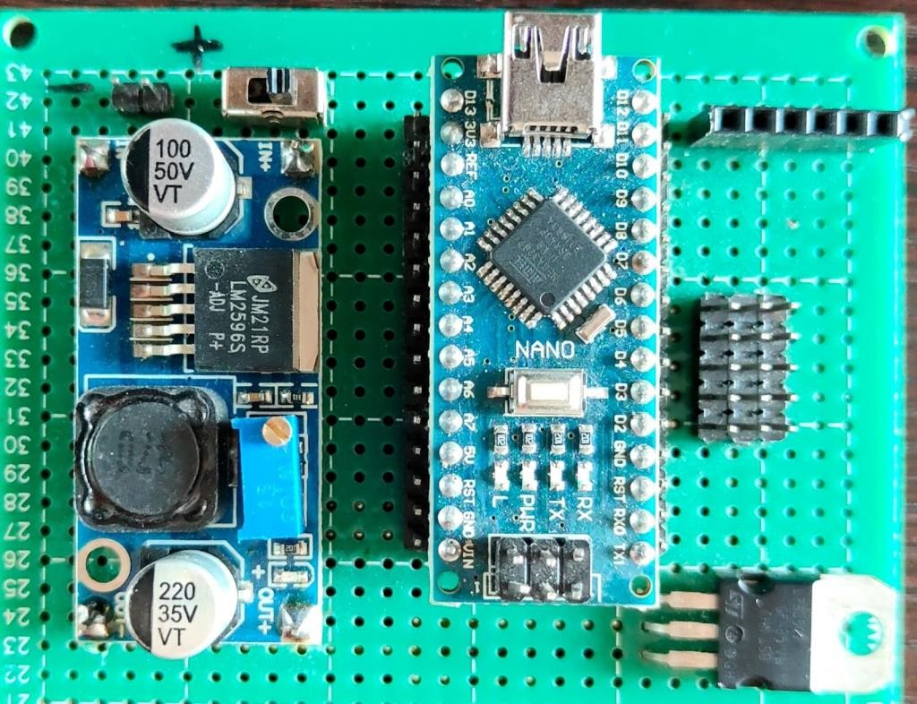

Fig 3.2.6.1 PCB Board

  - CODE

#include <SoftwareSerial.h> #include <Servo.h> SoftwareSerial bluetooth(10, 11);
Servo servoThumb, servoIndex, servoMiddle, servoRing, servoPinky; int prevPositions[5] = {0, 0, 0, 0, 0}; // Stores previous positions
bool isGripped = false; // Track if in grip mode void setup() {
Serial.begin(9600); bluetooth.begin(9600); servoThumb.attach(2); servoIndex.attach(3); servoMiddle.attach(4); servoRing.attach(5); servoPinky.attach(6);
}
void loop() {
if (bluetooth.available() > 0) {
String command = bluetooth.readStringUntil('\n'); command.trim();
executeCommand(command);
}
}
void executeCommand(String command) { if (command == "close thumb") { moveServo(servoThumb, 180);
} else if (command == "close index finger") { moveServo(servoIndex, 180);
} else if (command == "close middle finger") { moveServo(servoMiddle, 180);

} else if (command == "close ring finger") { moveServo(servoRing, 180);
} else if (command == "close little finger") { moveServo(servoPinky, 180);
} else if (command == "close all fingers") { openAllFingers(180);
} else if (command == "normal") { resetToNormal();
} else if (command == "grip") { grip();
} else if (command == "release") { release();
} else if (command == "one number") {
Servo* servos[] = {&servoThumb, &servoMiddle, &servoRing, &servoPinky}; int angles[] = {180, 180, 180, 180};
moveServos(servos, angles, 4); // Move 4 servos at one time
} else if (command == "two number") {
Servo* servos[] = {&servoThumb, &servoRing, &servoPinky}; int angles[] = {180, 180, 180};
moveServos(servos, angles, 3);
} else if (command == "three number") { Servo* servos[] = {&servoRing, &servoPinky}; int angles[] = {180, 180};
moveServos(servos, angles, 2);
} else if (command == "four number") { Servo* servos[] = {&servoPinky};
int angles[] = {180}; moveServos(servos, angles, 1);
} else if (command == "beautiful" || command == "nice") { Servo* servos[] = {&servoIndex, &servoThumb};

int angles[] = {180, 180};
moveServos(servos, angles, 2);
} else if (command == "cheers" || command == "shoot") { Servo* servos[] = {&servoRing, &servoThumb, &servoPinky}; int angles[] = {180, 180, 180};
moveServos(servos, angles, 3);
} else if (command == "best of luck") {
Servo* servos[] = {&servoRing, &servoIndex, &servoPinky, &servoMiddle}; int angles[] = {180, 180, 180, 180};
moveServos(servos, angles, 4);
} else if (command == "washroom") {
Servo* servos[] = {&servoRing, &servoThumb, &servoIndex, &servoMiddle}; int angles[] = {180, 180, 180, 180};
moveServos(servos, angles, 4);
} else if (command == "correct" || command == "right") { Servo* servos[] = {&servoRing, &servoMiddle, &servoPinky}; int angles[] = {180, 180, 180};
moveServos(servos, angles, 3);
} else if (command == "let's rock") {
Servo* servos[] = {&servoRing, &servoMiddle, &servoThumb}; int angles[] = {180, 180, 180};
moveServos(servos, angles, 3);
} else if (command == "slang") {
Servo* servos[] = {&servoRing, &servoIndex, &servoPinky, &servoThumb}; int angles[] = {180, 180, 180, 180};
moveServos(servos, angles, 4);
}
}
void moveServo(Servo &servo, int angle) { servo.write(angle);

delay(1000); servo.write(0);
}
void moveServos(Servo* servos[], int angles[], int numServos) { for (int i = 0; i < numServos; i++) {
servos[i]->write(angles[i]);
}
delay(1000);
for (int i = 0; i < numServos; i++) { servos[i]->write(0);
}
}
void openAllFingers(int angle) { moveServo(servoThumb, angle);
Servo* servos[] = {&servoIndex, &servoMiddle, &servoRing, &servoPinky}; int angles[] = {angle, angle, angle, angle};
moveServos(servos, angles, 4);
}
void resetToNormal() { servoThumb.write(0); servoIndex.write(0); servoMiddle.write(0); servoRing.write(0); servoPinky.write(0);
}
void grip() {
if (!isGripped) {
prevPositions[0] = servoThumb.read(); prevPositions[1] = servoIndex.read(); prevPositions[2] = servoMiddle.read();

prevPositions[3] = servoRing.read(); prevPositions[4] = servoPinky.read(); servoThumb.write(180); servoIndex.write(180); servoMiddle.write(180); servoRing.write(180); servoPinky.write(180);
isGripped = true;
}
}
void release() { if (isGripped) {
servoThumb.write(prevPositions[0]); servoIndex.write(prevPositions[1]); servoMiddle.write(prevPositions[2]); servoRing.write(prevPositions[3]); servoPinky.write(prevPositions[4]); isGripped = false;
}
}

  - PHOTOGRAPH OF PROJECT
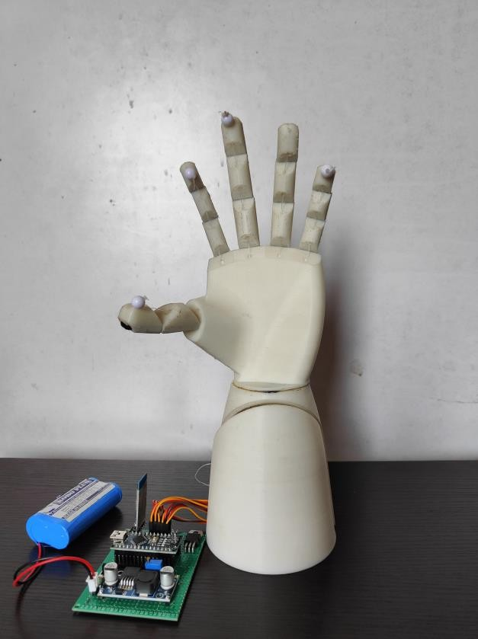
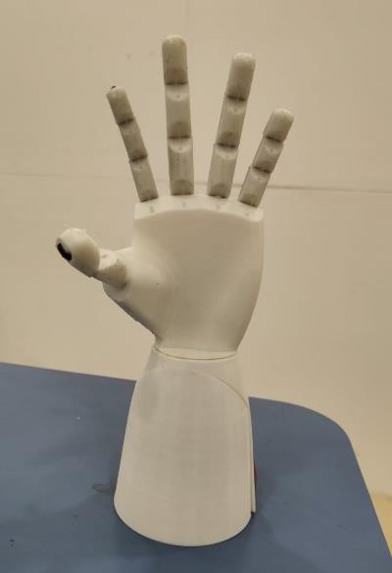

CHAPTER 4 APPLICATION

- Applications:

The intelligent pet feeder designed with real-time image recognition and IoT capabilities has a wide range of applications across individual households, public animal care programs, and institutional facilities. Its smart automation and adaptive control make it suitable for various settings where pet feeding consistency and efficiency are essential.

- Automated Home Pet Feeding

For individual pet owners, especially those with busy schedules, the system offers a reliable solution for ensuring pets are fed on time even in the owner's absence. Unlike traditional feeders that rely on fixed timers, this system ensures food is dispensed only when the pet is present, adding a layer of context awareness and reducing overfeeding or missed meals. This is particularly useful for working professionals or people who travel frequently.

- Feeding Systems for Street Animals

The pet feeder can be adapted for community use to support feeding programs for straydogs and cats. NGOs and animal welfare volunteers often face the challenge of managing food supplies efficiently. By using a motion-triggered, camera-based system, food is dispensed only when an animal is detected, helping prevent wastage and keeping the feeding stations clean and controlled.

- NGO or Community-Based Pet Care Initiatives

Animal welfare organizations that care for a large number of animals can implement this system to automate feeding while maintaining accountability and oversight. Real-time video monitoring adds transparency and allows volunteers to verify that food is being accessed by the intended animals.

- Remote Monitoring of Pet Feeding

With real-time video streaming through the ESP32-CAM, users can monitor their pets from any location with internet access. This adds peace of mind for pet owners and caregivers, allowing them to confirm feeding actions, observe animal behavior, and ensure overall pet well-being.

- Smart Pet Boarding and Kennel Facilities

Boarding facilities can integrate this intelligent feeding system to offer personalized, on demand feeding services for pets in their care. The ability to identify individual animals through image recognition allows staff to maintain customized feeding schedules, reduce human error, and improve service quality for pet owners.

- Veterinary Clinics and Animal Shelters

Clinics and shelters often house animals for extended periods. This feeder helps reduce the workload of caretakers by automating part of the daily routine. With object recognition, the system ensures animals are actually present before food is dispensed, improving operational efficiency and reducing waste.

- Integration with Smart Home Systems

The intelligent pet feeder can be further integrated with smart home ecosystems using IoT protocols. Through mobile applications or voice assistants (e.g., Alexa, Google Assistant), pet owners can interact with the feeder, receive alerts, or manually trigger food dispensing, making pet care more interactive and intelligent.

CHAPTER 5 CONCLUSION

CONCLUSION
The development of the Intelligent Pet Feeder with Real-Time Camera Monitoring successfully demonstrates how the integration of IoT and computer vision can transform traditional automated systems into smart, adaptive solutions. By leveraging the ESP32- CAM for real-time video streaming and the YOLOv3 object detection algorithm for pet presence identification, the system eliminates reliance on fixed-time dispensing and introduces behaviour-based feeding logic.

The feeder dispenses food only when a pet is actually present and includes a buffer mechanism to prevent overfeeding, promoting healthier eating habits and reducing food wastage. The system’s modular hardware—featuring the NEMA 17 stepper motor, TB6600 driver, and LED indicators—worked reliably under various conditions during testing. The use of cost-effective and open-source components enhances the system's accessibility and scalability, making it suitable for households, animal shelters, and pet care facilities.

This project not only validates the technical feasibility of presence-based feeding automation but also highlights the broader potential for AI and embedded systems in domestic animal care. With minimal hardware and efficient software integration, the feeder serves as a robust platform for future enhancements.

This feeder not only streamlines daily pet care for busy owners but also offers scalable applications for community-based feeding programs, animal shelters, and remote monitoring scenarios. Its modular design and open-source software framework allow further customization, such as cloud-based analytics, mobile notifications, and low-power operations. Moreover, the choice of cost-effective yet powerful components make the solution accessible for both hobbyists and professional adopters.

Overall, this project validates the feasibility of intelligent feeding systems that combine Internet of Things (IoT) hardware with state-of-the-art artificial intelligence. It paves the way for more sophisticated pet care solutions that prioritize animal welfare, operational efficiency, and user convenience, setting a solid foundation for future innovations in automated pet care technology

FUTURE SCOPE
The Intelligent Pet Feeder system has demonstrated a successful fusion of IoT, computer vision, and automation. However, there are several opportunities to enhance the system's features, scalability, and real-world applicability in the future.

One of the most significant advancements would be the integration of a mobile application that allows users to monitor pet activity remotely, receive notifications about feeding status, and manually control the feeder if required. This app could also offer a dashboard displaying historical feeding data, pet presence logs, and camera snapshots.

Another promising extension is the implementation of cloud storage and data analytics. By storing detection logs and camera footage in the cloud, pet owners can analyze feeding patterns, detect anomalies in pet behaviour, and receive intelligent recommendations. This would also enable veterinarians to monitor dietary habits for health assessments.

The system can be upgraded with voice output modules or audio playback features to call pets to the feeding station when food is dispensed. This would increase the feeder’s usability for shy or distant animals.

Integrating solar panels or low-power modes could make the feeder more energy- efficient and suitable for outdoor or remote locations, especially for community feeding stations. This would eliminate the need for constant power supply and ensure uninterrupted service in rural or stray animal care setups.

In terms of AI, implementing newer versions of object detection algorithms like YOLOv5 or YOLOv8, or incorporating custom-trained models specifically tuned for pet detection, could improve detection speed and accuracy.

Finally, expanding the system to support multiple pet profiles, face recognition, or RFID tagging could help differentiate between animals, ensuring personalized feeding schedules and quantities. This would be especially useful in multi-pet households or pet shelters.

These future enhancements will not only elevate the system’s functionality but also broaden its scope to support more intelligent, sustainable, and personalized pet care solutions.

The Intelligent Pet Feeder with Real-Time Camera Monitoring presents a comprehensive, reliable, and efficient solution for modern pet care. By integrating IoT hardware, AI- based object detection, and smart automation, the system ensures pets receive timely and appropriate feeding without requiring constant human supervision. It bridges the gap between manual feeding and fully intelligent pet care, benefiting both pet owners and animal welfare initiatives. With potential for future enhancements like remote

notifications and cloud integration, this project lays the foundation for next-generation smart pet care systems.

REFERENCES
- W.-C. Wu, K.-C. Cheng, and P.-Y. Lin, "Remote Pet Feeder ControlSystem via MQTT Protocol," IEEE, 2018.

- P. V. Prithviraj and K. C. Sriharipriya, "Smart Pet Feeder System Basedon Google Assistant," IEEE, 2022.

- V. P. N. Vrishanka, K. Rupali, D. Shet, and P. Prabhakar, "AutomatedPet Feeder using IoT," IEEE, 2021.

- K. Jaiswal, "IoT Based Pet Feeding System," B.Tech. thesis, Electronics and Communication Engineering, Jaypee University of Information Technology, Waknaghat, 2021, under the guidance of Dr.Alok Kumar.

- Adriansyah, M. A. Wibowo, and E. Ihsanto, "Design of Pet Feederusing Web Server as Internet of Things Application," Department of Electrical Engineering, Faculty of Engineering, Universitas Mercu Buana, Jakarta, Indonesia.

- "Automatic Pet Monitoring and Feeding System Using IoT" was published by IJCR in 2017. In 2016, the 2nd International Conference on Electrical Engineering (Icon-IEE) published "Design of Pet Feeder Using Web Server as Internet of Things Application."

- "IoT Research and Applications in Pet Systems" This paper was published (http://www.scirp.org/journal/ait) and included Chinese students in 2019.

- "Arduino-Based Automatic Pet Feeder" The International Journal of Innovative Research in Science published this paper. (IJIRSET) was published in 2018.

- M. Pardo, L. G. Kwong, G. Sberveglieri, J. Schneider, W. R. Penrose, and J. R. Stetter, Detection of Contraband Food Products Using a Hybrid Chemical Sensor System, IEEE, 2021) 1073-1076.

- Vania, Kanisius Karyono, Hargyo Tri Nugroho. Computer Engineering, Multimedia Nusantara University, Tangerang, Indonesia: Smart Dog Feeder Design Using Wireless Communication, MQTT and Android Client 2016 International Conference on Computer, Control, Informatics and its Applications, DOI: 10.1109/IC3INA.2016.7863048, 978-1-5090-2323-3/16/$31.00 c 2016 IEEE.

- Tessema Gelila Berhan, Worku Toyiba Ahemed, Tessema Zelalem Birhan. Tianjin University of Technology and Education (TUTE), School of Electronics Engineering, Tianjin: Programmable Pet Feeder, International Journal of Scientific Engineering and Research (IJSER), Volume 3 Issue 11, November 2015 ISSN (Online): 2347-3878, Impact Factor (2014): 3.05.

- Raed Abdulla, Ahmed Abdelkader Eldebani, Sathish Kumar Selvaperumal, Mayhem K. Abbas.School of Engineering, Asia Pacific University of Innovation and Technology (APU), Faculty of Science & Information Technology, University Teknologi PETRONAS, Malaysia. Volume 83 Page Number: 269 - 279 Publication Issue: March - April 2020.

- Vania, “Perancangan Smart Dog Feeder Menggunakan Protokol Komunikasi WiFidan MQTT Serta Client Berbasis Android,” Universitas Multimedia Nusantara, Tangerang, Skripsi 2016.

- Even Yehudah Ofer Landau, "Dry Food Dispensing System," US 6,964,355 B2, Nov. 15, 2005.

- Luigi Atzori, Antonio Iera, Giacomo Morabito, “The Internet of Things: A Survey”, Elsevier, May 2010. 27

- Saurabh A. Yadav, Sneha S. Kulkarni, Ashwini S. Jadhav, Prof. Akshay R. Jain, Computer engineering, PVGCOEN, Maharashtra, INDIA, “IOT BASED PET FEEDER SYSTEM”, Vol-4 Issue-2 2018 IJARIIE-ISSN(O)-2395-4396.

- Yixing Chen, Maher Elshakankiri Department of Computer Science University of Regina Regina, Canada, “Implementation of an IoT based Pet Care System”, 2020 Fifth International Conference on Fog and Mobile Edge Computing (FMEC), 978-1-7281- 7216- 3/20/$31.00 ©2020 IEEE.

- Luayon, G. Tolentino, V. Almazan, P. Pascual, and M. Samonte, “PetCare: A Smart Pet Care IoT Mobile Application”, in IC4E 2019: 2019 10th International Conference on E-Education, E-Business, management and E-Learning, Tokyo, 2019, pp. 427–431.

- S.Subaashri, M.Sowndarya, D.K.S. Sowmiyalaxmi, S.V.Sivassan, and C. Rajasekaran, “Automatic Pet Monitoring and Feeding System Using IoT”, International Journal of ChemTech Research, vol. 10, no. 14, pp. 253-258, 2017.

- Priya Mondal, Dr. Swapnili Karmore, Rajnandnee Parnami Mukt Shabd Journal, “Design and development of IoT based Smart Pet Feeder”, ISSN NO: 2347- 3150, Volume IX, Issue V, MAY/2020.

ANNEXURE

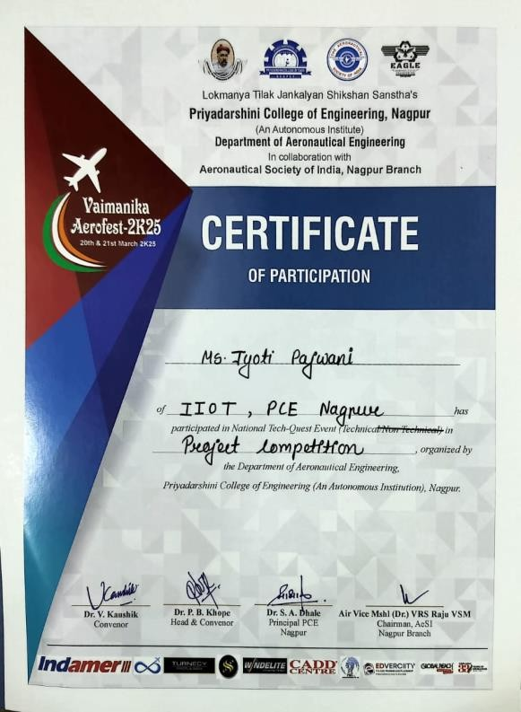
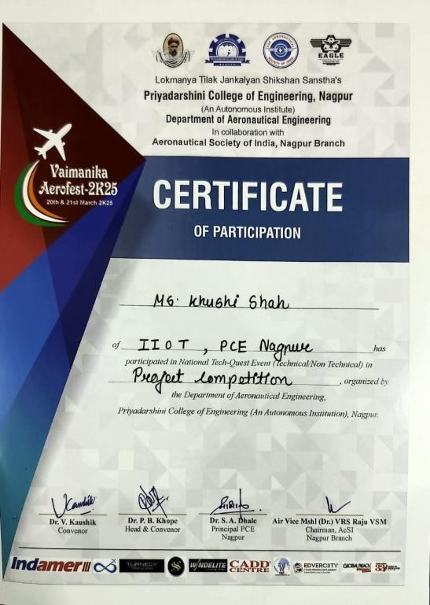
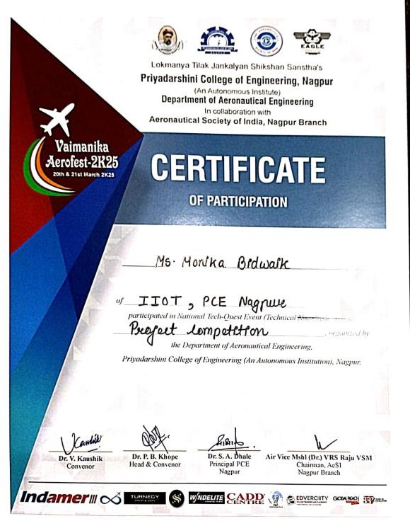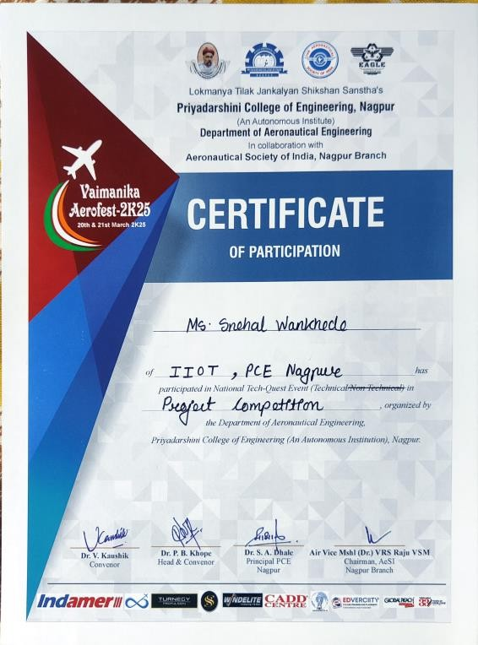


GUIDES AND PROJECTEES INFORMATION GUIDE DETAILS:
Name: Prof. Divya Meshram
Designation: Assistant Professor (IIOTDept.) Email Id: divyameshram@gmail.com Mobile No. : 9421704683

PROJECTEES DETAILS:

- Name: Jyoti Panjwani Class Roll No. 102
Enrollment No: 2021016600946864 Email Id: panjwanijyoti2003@gmail.com Mobile No. : 7350813236


- Name: Khushi Shah Class Roll No: 103
Enrollment no: 2021016600945903
E-mail Id: khushishahu907@gmail.com Mobile No. : 9022485335


- Name: Monika Bidwaik Class Roll No: 105
Enrollment no: 2021016600947121
E-mail Id: monikabidwaik317@gmail.com Mobile No. : 9834784927


- Name: Snehal Wankhede Class Roll No: 109
Enrollment no: 20231027822898
E-mail Id: snehalwankhede2904@gmail.com Mobile No. : 9359300736

Thank You!

46

